ACC 2 Field Upgrade Instructions

Step 1: Insert the SD Card into a PC and copy all EFI files into the SD Card.
Step 2: Insert the SD Card with the update files into the Facepack SD Card Slot.
Step 3: From the Home screen, press the Main Menu softkey.


Step 4: Navigate to Advanced Features.
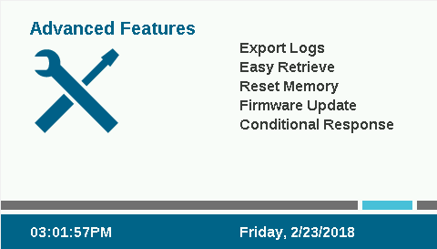
Step 5: Press the scroll wheel, then scroll down until Firmware Update is highlighted blue and press the scroll wheel.

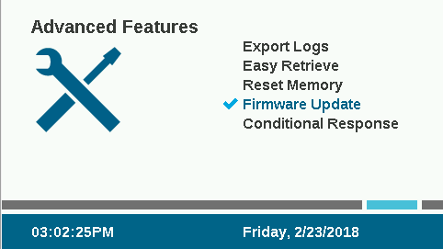

Step 6: Press the Update softkey and confirm the choice by highlighting “Yes” and pressing the scroll wheel.
Note: Red X’s as seen in the screenshot below denotes that a file for that module was not found and will not be updated. If this occurs please re-download the file onto the SD and re-insert and wait for the red X to become a Blue Check Mark.
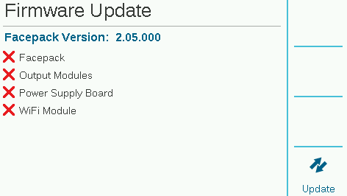

Update will execute then reset. Once the Home screen is displayed, the update is complete.

